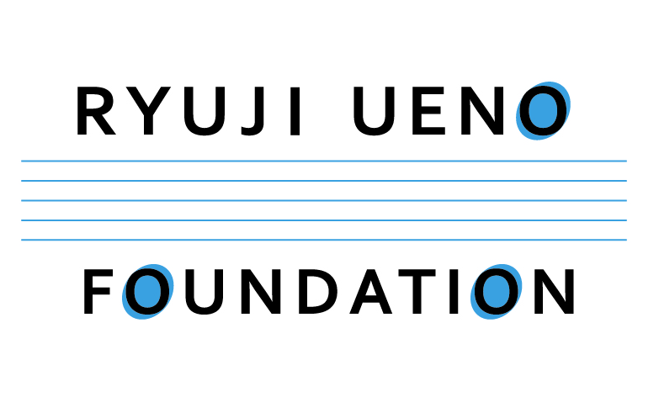
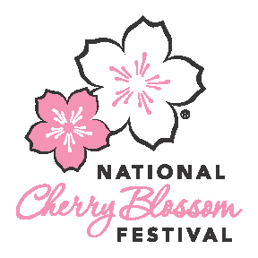

FOR IMMEDIATE RELEASE

CONTACT: Nora Strumpf
202.638.8374
nstrumpf@ncbfdc.org

THE 6821 QUINTET COME TOGETHER FOR 2017 NATIONAL CHERRY BLOSSOM FESTIVAL

Washington, DC [March 1, 2017] – The 6821 Quintet, a quintet assembled specifically for the 2017 National Cherry Blossom Festival, will offer rare musical performances for three days only.

Named after the distance between Washington DC and Tokyo, the quintet was created by The Ryuji Ueno Foundation as part of the Potomac Music Lab Project. The group’s world-renowned musicians will perform a variety of classical and popular songs for a salon series “Evermay Concert Series” in Georgetown (Friday March 24, 7:30pm), for the Festival’s Opening Ceremony on Saturday, March 25 at the Warner Theatre, and as a pop-up performance at Union Station (March 26, noon).

The 6821 Quintet will be led by violinist Mayu Kishima, First Prize winner of the First Shanghai Isaac Stern International Violin Competition in 2016. Using the finest classical instruments, the group is comprised of two violinists, a violist, a cellist, and a pianist. The quintet premieres pieces specifically composed for the National Cherry Blossom Festival; this year’s work will be composed by S&R Foundation Washington Award Winner Mamiko Hirai.
“We are extremely excited to perform during the National Cherry Blossom Festival as a gesture of friendship between Japan and the U.S.,” said Dr. Ryuji Ueno, Founder and Executive Director of The Ryuji Ueno Foundation, sponsor of The 6821 Quintet. “We are honored to have the opportunity to share the innovative sounds of classical music performed by these amazing artists with incomparable style and flawless technique to the DC community."
Dr. Ryuji Ueno received the 2015 Mayor’s Art Award for Visionary Leadership at the 30th annual Mayor’s Art Awards. His Potomac Music Lab Project serves as an incubator for classical music, where world-class musicians can experiment with their craft.
The quintet’s performances are part of the National Cherry Blossom Festival’s community outreach initiatives, which extend the organization’s mission throughout the region. The free pop-up performance at Union Station aims to highlight the city’s gateway as an unconventional yet unique setting for world-class performances.

“The Festival prides itself on showcasing diverse and unique talent throughout the region, and we are proud to have the 6821 Quintet return again this year,” said Diana Mayhew, President of the National Cherry Blossom Festival.

The National Cherry Blossom Festival is the nation’s greatest springtime celebration. The 2017 Festival, March 20 – April 16, includes four weeks of events featuring diverse and creative programming promoting traditional and contemporary arts and culture, natural beauty, and community spirit. Visit nationalcherryblossomfestival.org or call 877.44.BLOOM for more information and find us on Facebook (CherryBlossomFestival), Twitter (@CherryBlossFest), and Instagram (@CherryBlossFest).
###

